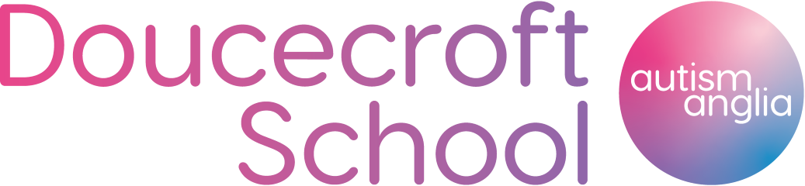

Dear Parents / Carers

PE Kit and Uniform

All students must wear suitable clothing for school and also to be able to participate in PE activities. We are able to supply suitable clothing items for students, all of which will include the school logo. Costs are provided below.

To place an order, please complete the form below and return it to school.

Please ensure that you select the correct sizes when ordering.
………………………………………………………………………………………………………………………………………………………

PE Kit & Uniform Order Form

Name of student:

Price

………. PE Shirt – Size …………………………………………... £11

………. PE Shorts – Size …………………………………………... £10

………. PE ¼ Zip Top – Size …………………………………………... £21

………. Jogging Bottoms – Size…………………………………………... £20

………. Rain Jacket – Size …………………………………………... £17

………. PE Bag……………………………….Please tick if required £7

………. Long Sleeve PE Shirt – Size…………………………………... £14

………. PE Hoodie – Size …………………………………………... £17

I enclose cash or a cheque made payable to Autism Anglia for £

Signed: Date:
PE Kit

PE Shirt - £11 PE Shorts - £10
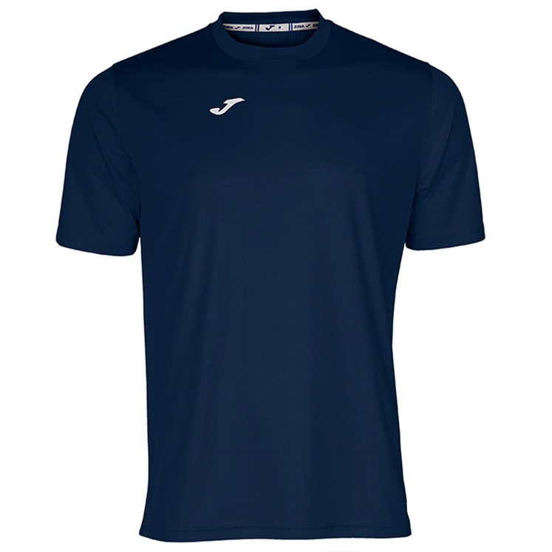
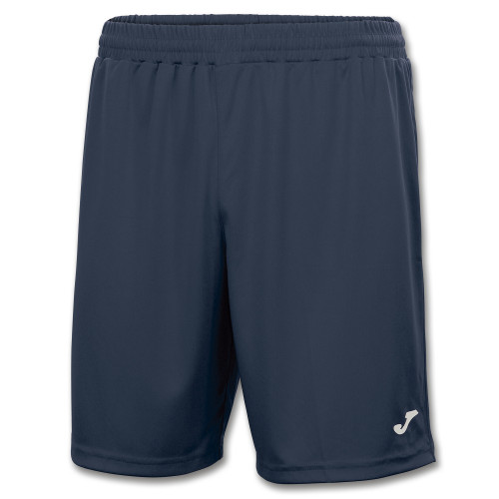

PE ¼ Zip Top - £21 Jogging Bottoms - £20

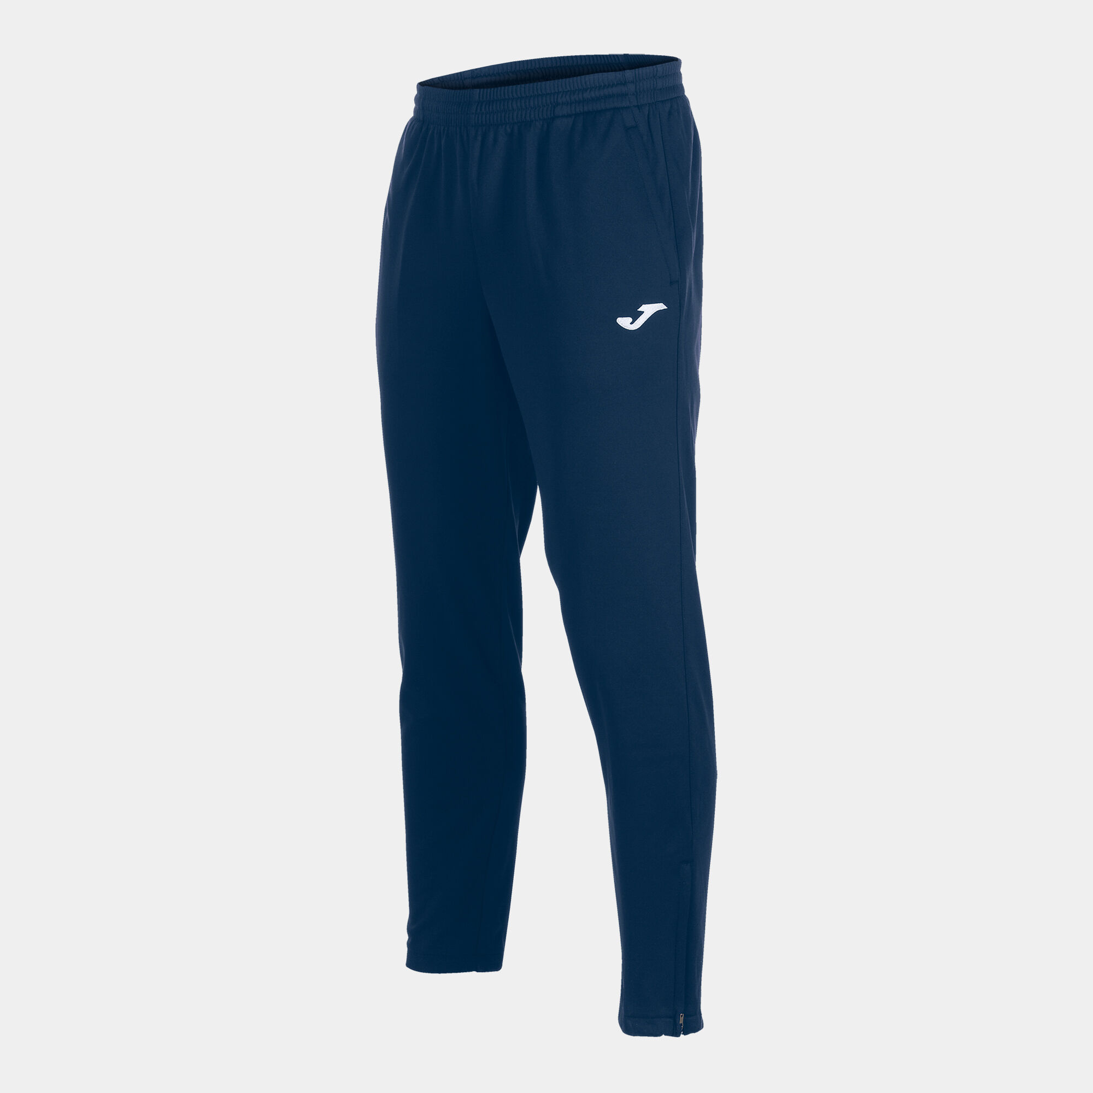
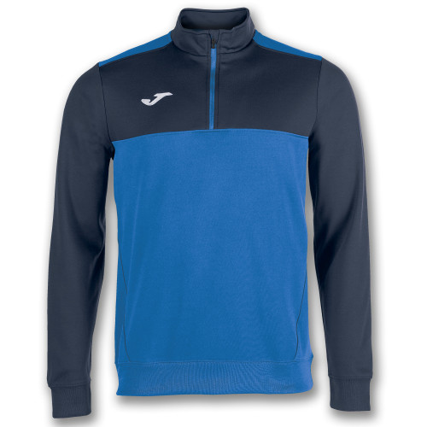

Optional Items

Rain Jacket - £17 PE Bag - £7
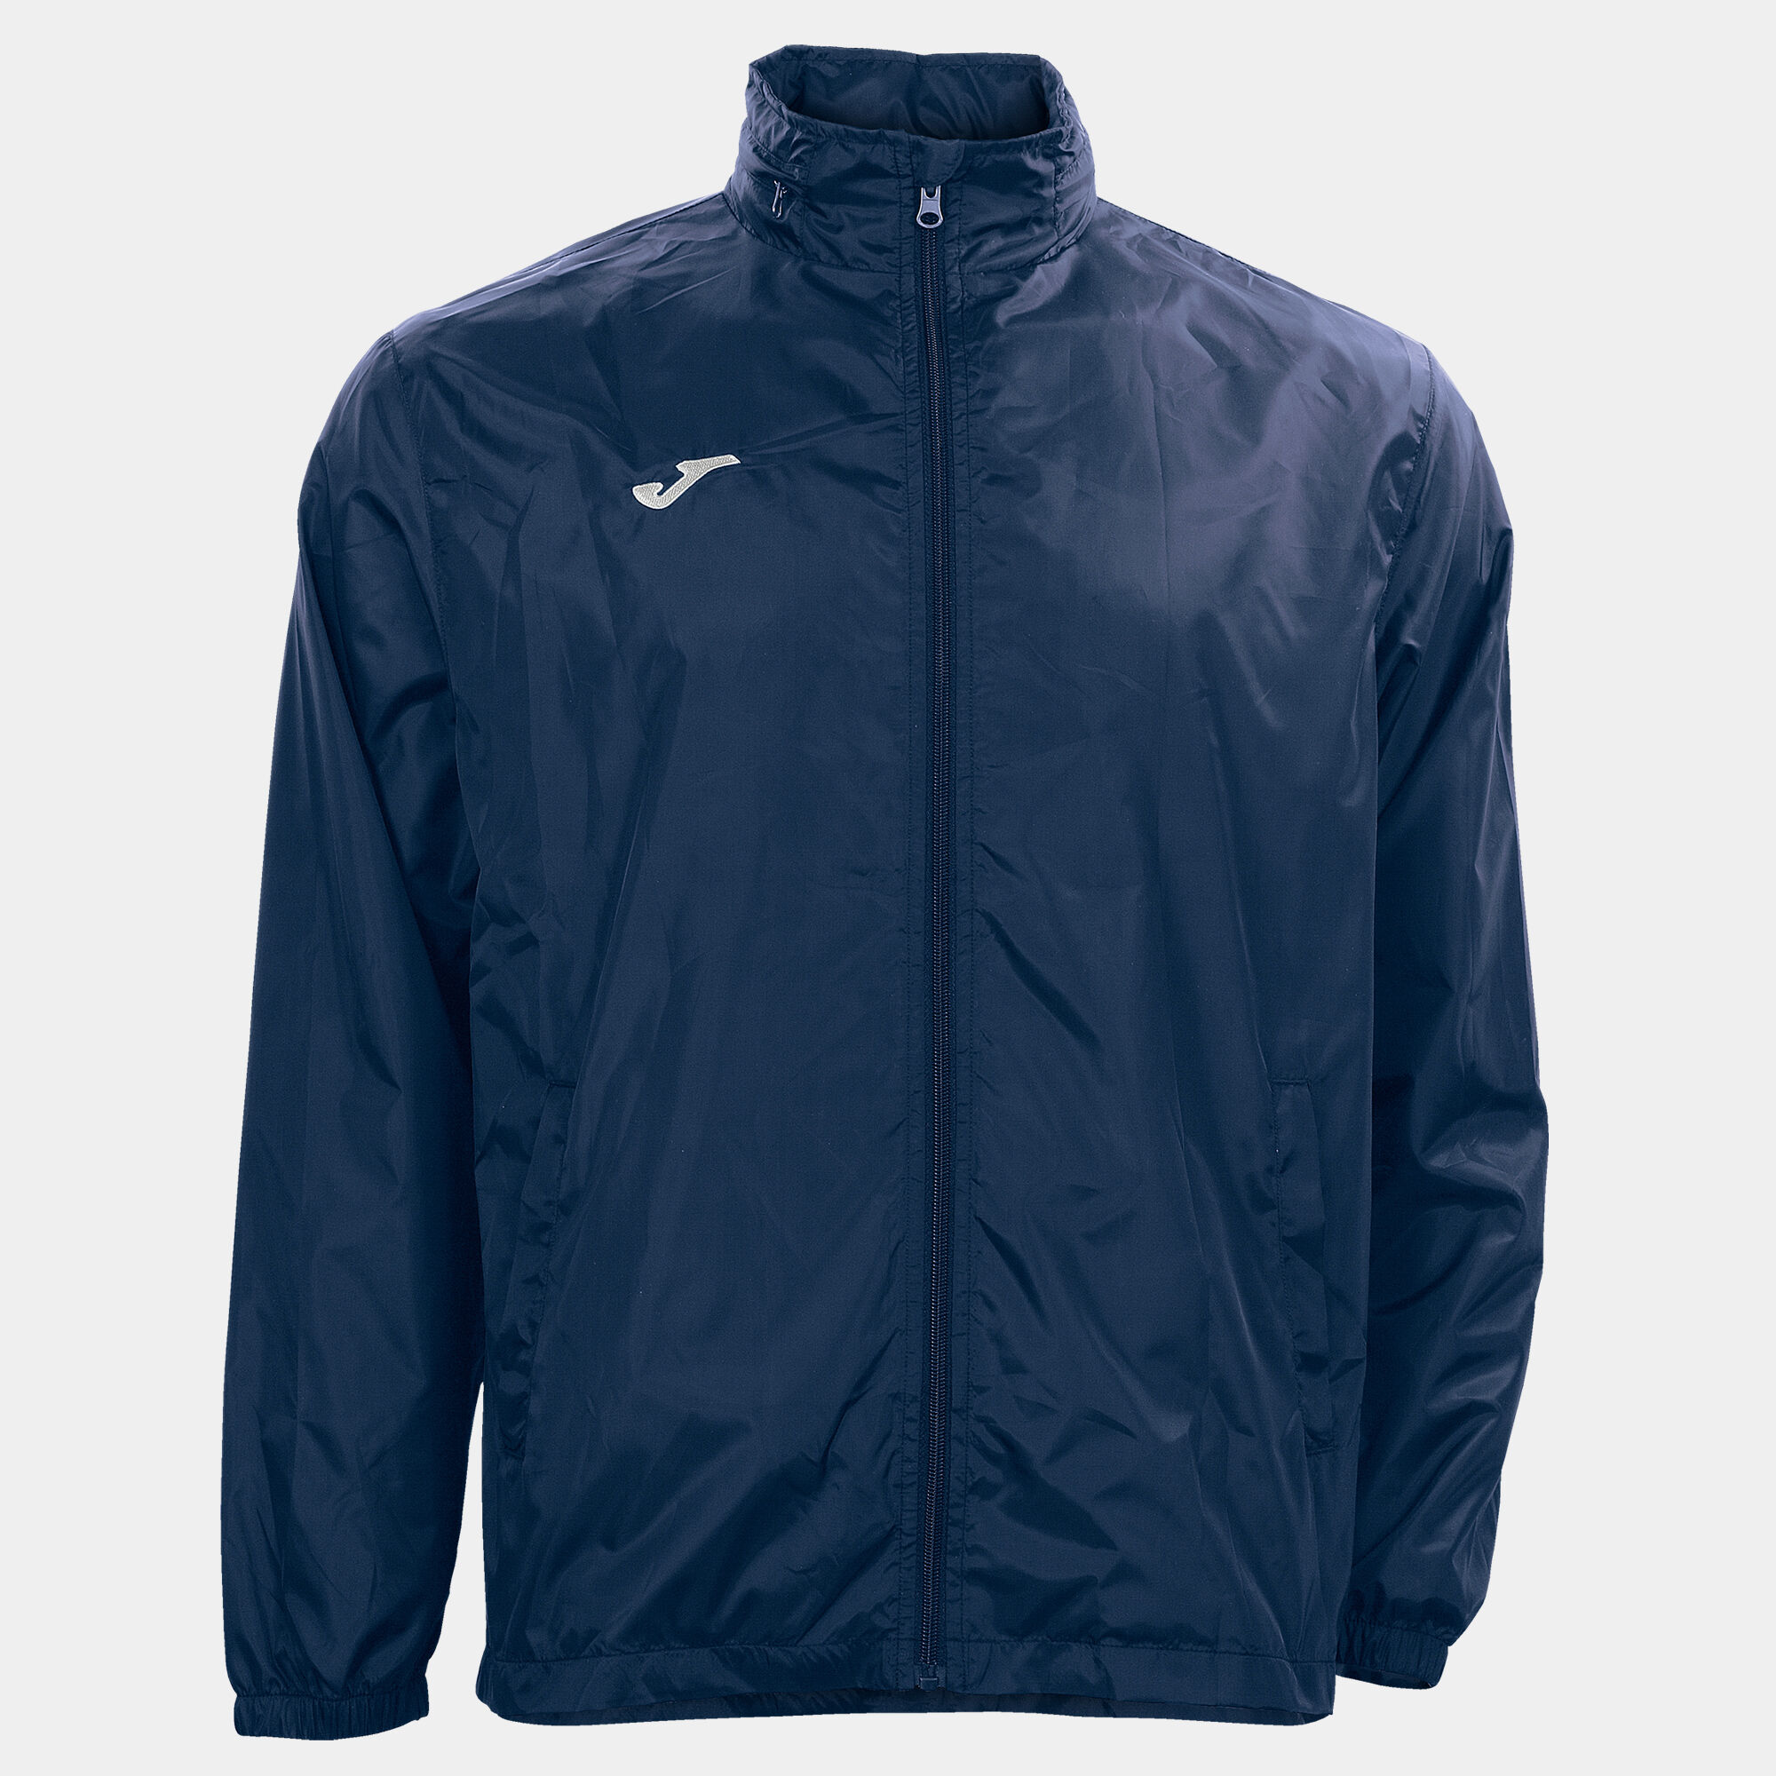
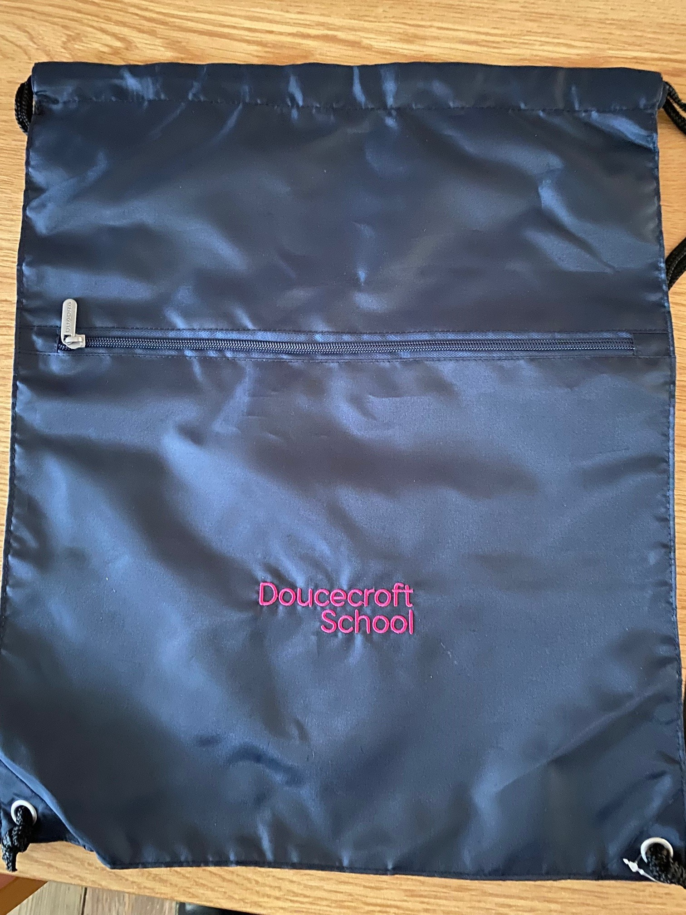

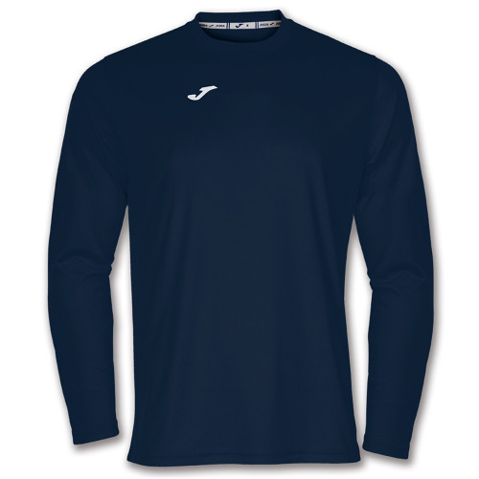
Long Sleeve PE Shirt - £14 PE Hoodie - £29
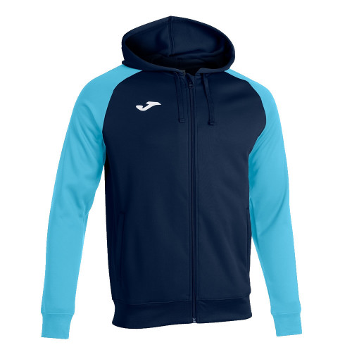

This may be used instead of the short sleeve This may be used instead of the ¼
PE shirt if preferred Zip Top If Preferred

Size Guide For All PE Kit Items
