Dear Parents / Carers
PE Kit and Uniform
All pupils must wear suitable clothing for school and to be able to participate in PE activities. We are able to supply a range of uniform and PE kit items, all featuring the school logo.
Please review the information below carefully before placing your order.

Junior item prices include VAT on embroidery only.
Adult item prices include VAT on both item and embroidery.

To place an order, please complete the form below and return it to school, ensuring you select the correct sizes when ordering.

Item | Number of items Required | Size | Item Price (all prices inc VAT as noted above) | Total Price
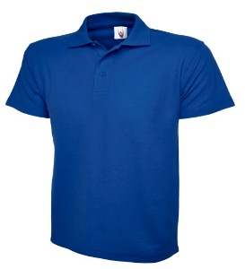  Junior Royal Blue Polo Shirt with logo  24/26” (age 3 to 4)  26/28” (age 5 to 6)  28/30” (age 7 to8)  30/32” (age 9 to 10)  32/34” (age 11 to 13) |  |  | £11.85
Adult Royal Blue Polo Shirt with logo  Picture as above – Available in sizes:  36-38” (Extra Small)  38/40” (Small)  40/42” (Medium)  42/44” (Large) |  |  | £13.40
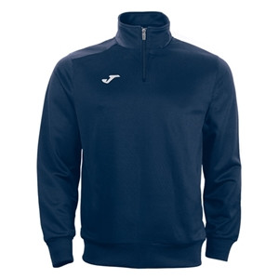  Junior PE ¼ Zip Navy Top with logo  See Joma Size Guide |  |  | £23.10
Adult PE ¼ Zip Navy Top with logo  Picture as above – See Joma Size Guide |  |  | £27.70
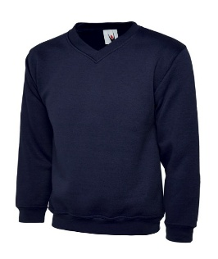  Junior Navy V-Neck Sweatshirt with logo  24/26” (age 3 to 4)  26/28” (age 5 to 6)  28/30” (age 7 to8)  30/32” (age 9 to 10)  32/34” (age 11 to 13) |  |  | £15.60
Adult Navy V-Neck Sweatshirt with logo  Picture as above – Available in sizes:  36-38” (Extra Small)  38/40” (Small)  40/42” (Medium)  42/44” (Large) |  |  | £21.85
Junior PE Shirt with logo  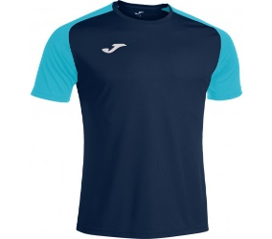  See Joma Size Guide |  |  | £17.35
Adult PE Shirt with logo  Picture as above – See Joma Size Guide |  |  | £19.80
Junior Navy PE Shorts with logo  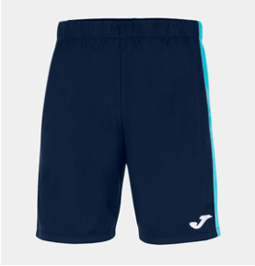  See Joma Size Guide |  |  | £14.10
Adult Navy PE Shorts with logo  Picture as above – See Joma Size Guide |  |  | £14.85
Junior Long Sleeve Navy PE Shirt with logo  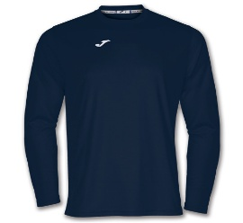  See Joma Size Guide |  |  | £15.90
Adult Long Sleeve Navy PE Shirt with logo  Picture as above – See Joma Size Guide |  |  | £18.60
Junior Navy Jogging Bottoms with logo  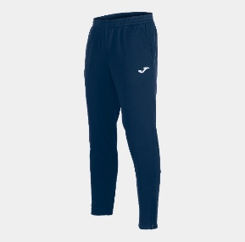  See Joma Size Guide |  |  | £24.90
Adult Navy Jogging Bottoms with logo  Picture as above – See Joma Size Guide |  |  | £28.50
Junior Navy Rain Jacket with logo  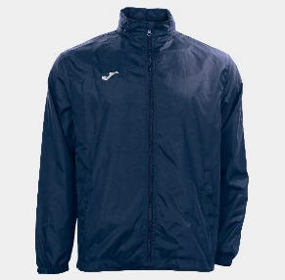  See Joma Size Guide |  |  | £21.60
Adult Navy Rain Jacket with logo  Picture as above – See Joma Size Guide |  |  | £23.20
PE Bag in Navy with logo (one size)  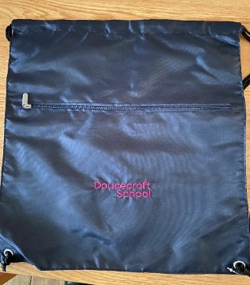 |  |  | £11.10
I enclose cash or a cheque made payable to Autism Anglia for £
Payment may also be made by bank transfer:
Account Name: Autism Anglia
Account Number: 11528930
Sort Code: 16-16-31

Paid using reference:

Signed: Dated:

